Muscles, Bones & Joints INVESTIGATION | Name:______________________ (______/30)

Study the images of a long-bone

1. a) Name the structures labelled:

A: ______________________________________ (hollow)

D: ______________________________________ (covering)

b) What type of bone is found at position

B: ______________________________________

C: ______________________________________
(4 marks)
2. What would you expect to find filling structure A?

_______________________________________________ (1 mark)

3. What is ONE function of structure D?

_____________________________________________________________ (1 mark)

4. Structure B is not solid, but instead it is composed of trabeculae. Explain two (2) structural benefits of the trabeculae to the bone.

________________________________________________________________________________

________________________________________________________________________________

________________________________________________________________________________

________________________________________________________________________________
(2 marks)

5. Name ONE long bone in the human body

_______________________________________________ (1 mark)

6. What are the TWO types of joints this bone will make at either end?

________________________________________________________________________________

________________________________________________________________________________
(2 marks)
Study the images of a dissected chicken wing
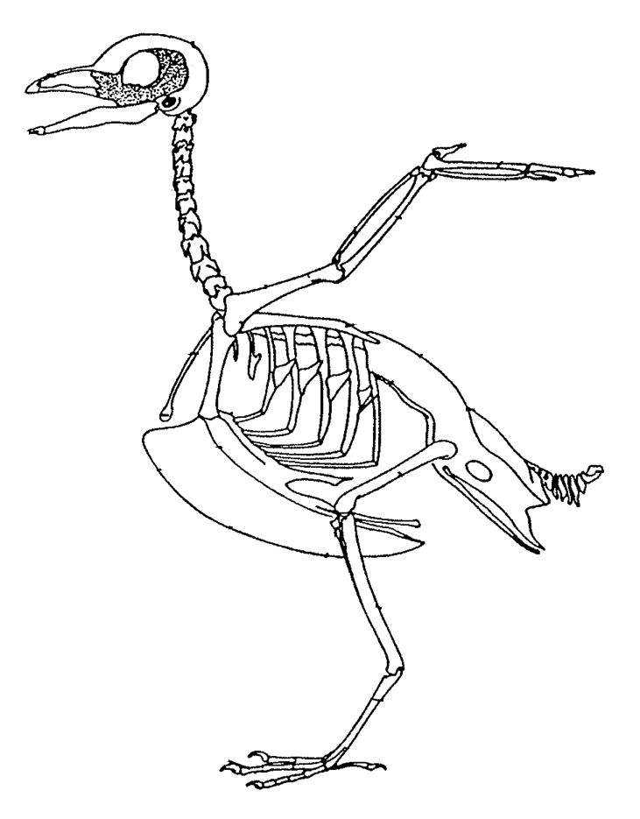
7. Draw in the flexor and extensor muscles as well as the tendons and cartilage on the diagram below that are required to move the wing.

Use coloured pencils to shade in your additions and match this with the colour key below.

HINT: draw the muscles in lead pencil first – then colour them in.
Draw the muscles as simply as possible

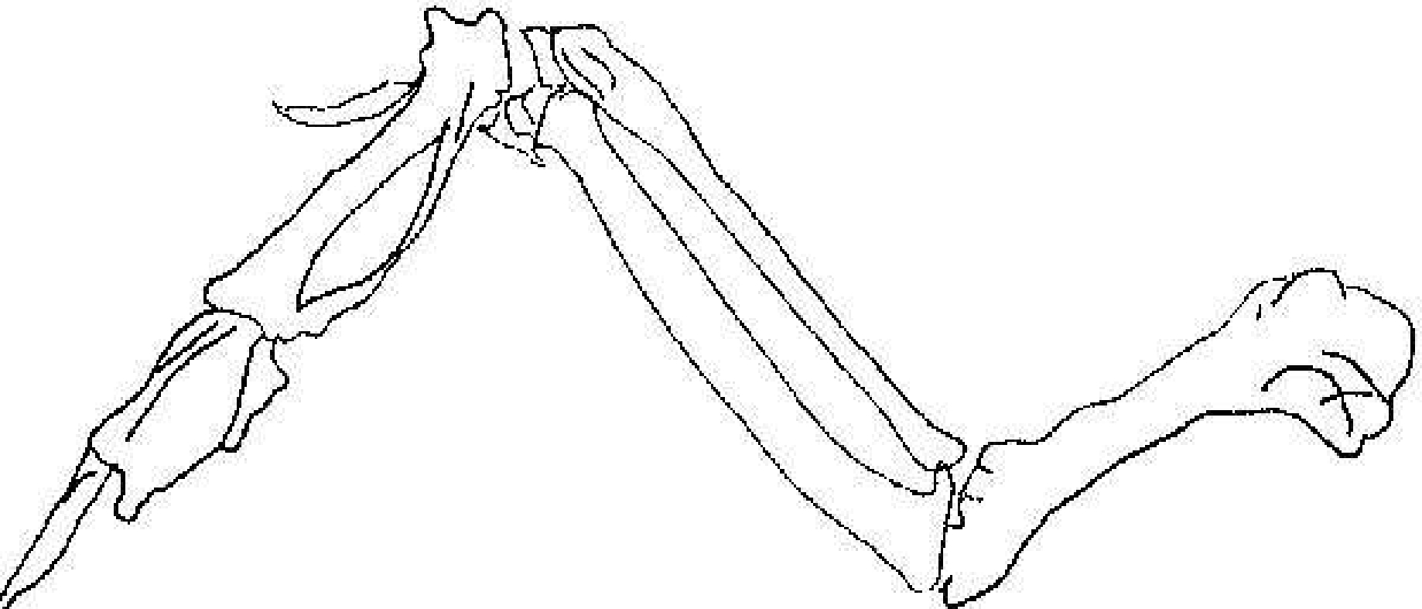

Colour Key

 = Flexor  = Extensor  = Tendon  = Cartilage
(4 marks)
8. Label the Humerus, Radius, Ulna, and Phalanges on the chicken and human bones on the diagrams below.

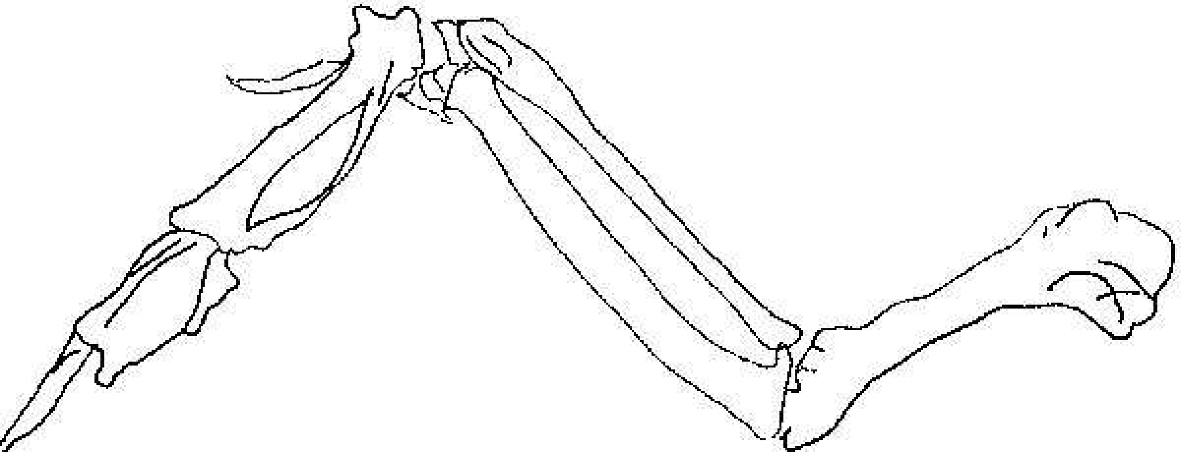

(4 marks)

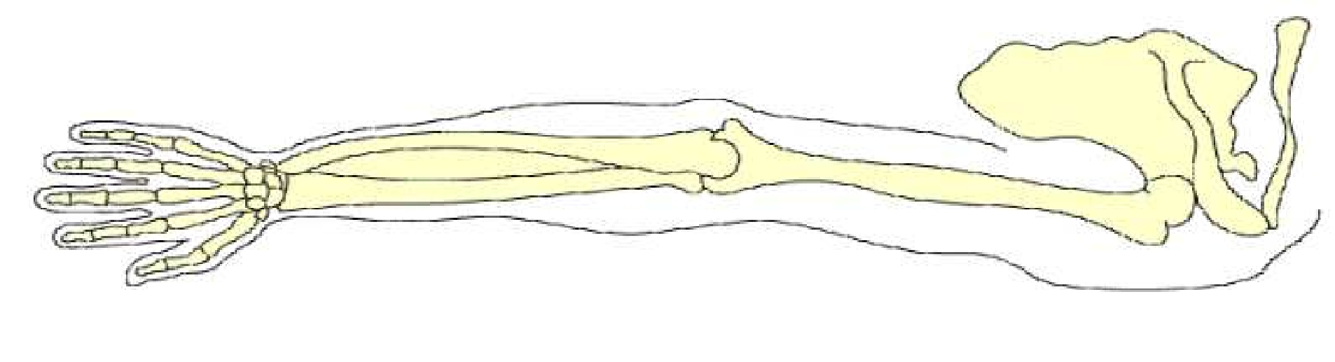

(4 marks)

9. Why are some bones irregularly shaped, or have notches, as opposed to smooth, rounded ends?

________________________________________________________________________________

________________________________________________________________________________

________________________________________________________________________________

________________________________________________________________________________

________________________________________________________________________________
(2 marks)

10. Based on your observations, explain the roles of muscles, tendons, and bones in the area labelled X when moving the wing back-and-forth. Choose words from the box below in your answer.

tricep flexor extensor bicep radius ulna humerus

X

________________________________________________________________________________

________________________________________________________________________________

________________________________________________________________________________

________________________________________________________________________________

________________________________________________________________________________

________________________________________________________________________________

________________________________________________________________________________

________________________________________________________________________________

________________________________________________________________________________

________________________________________________________________________________

________________________________________________________________________________

________________________________________________________________________________

________________________________________________________________________________

________________________________________________________________________________

(5 marks)

